Implement the concept given in below blog link and share the complete steps along with

screenshots.

<https://acadgild.com/blog/loading-data-into-hbase-using-pig-scripts/>

**Data copied to HDFS**

hadoop dfs -put /home/cloudera/student.txt /user

hadoop dfs -ls /user

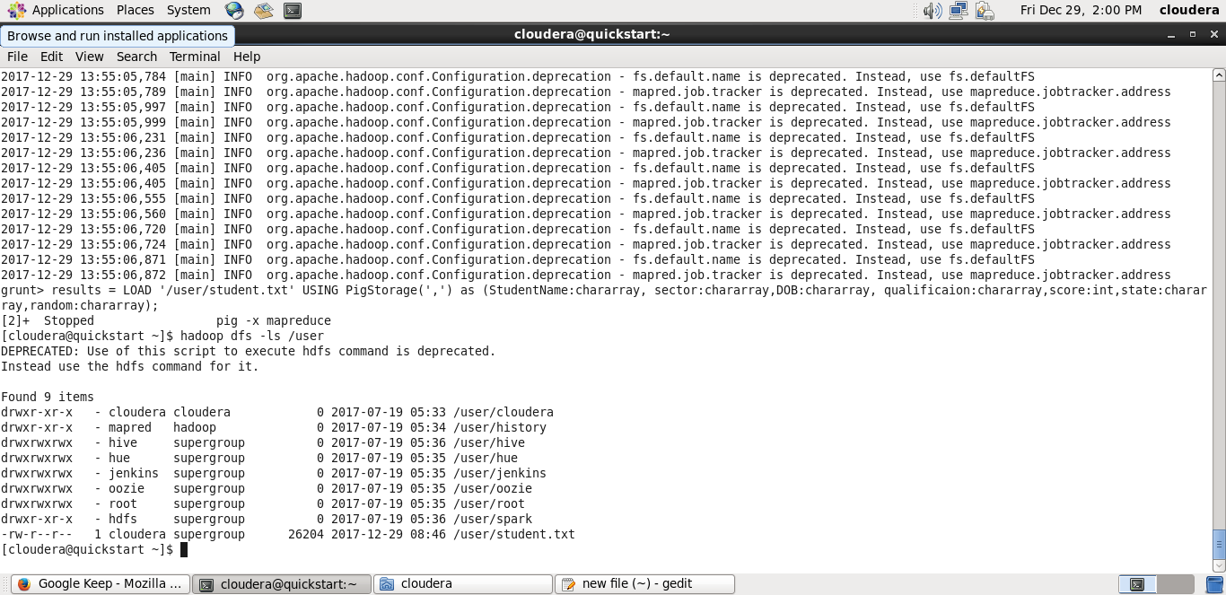

**Data in student.txt**

Hadoop dfs -cat /user/student.txt

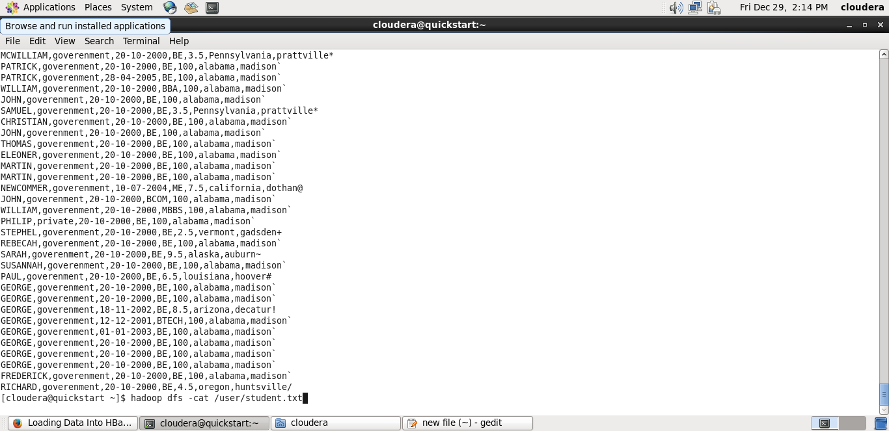

**Hbase table created**

>hbase shell

reate ‘studentAcad’,’student_data’

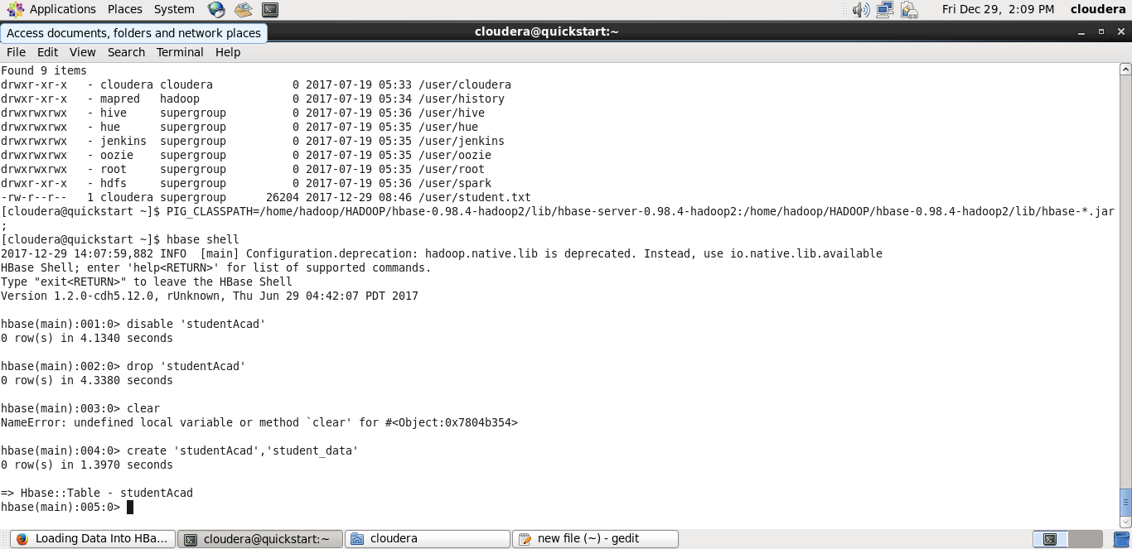

**Adding jar files**

PIG_CLASSPATH=/home/hadoop/HADOOP/hbase-0.98.4-hadoop2/lib/hbase-server-0.98.4-hadoop2:/home/hadoop/HADOOP/hbase-0.98.4-hadoop2/lib/hbase-*.jar;

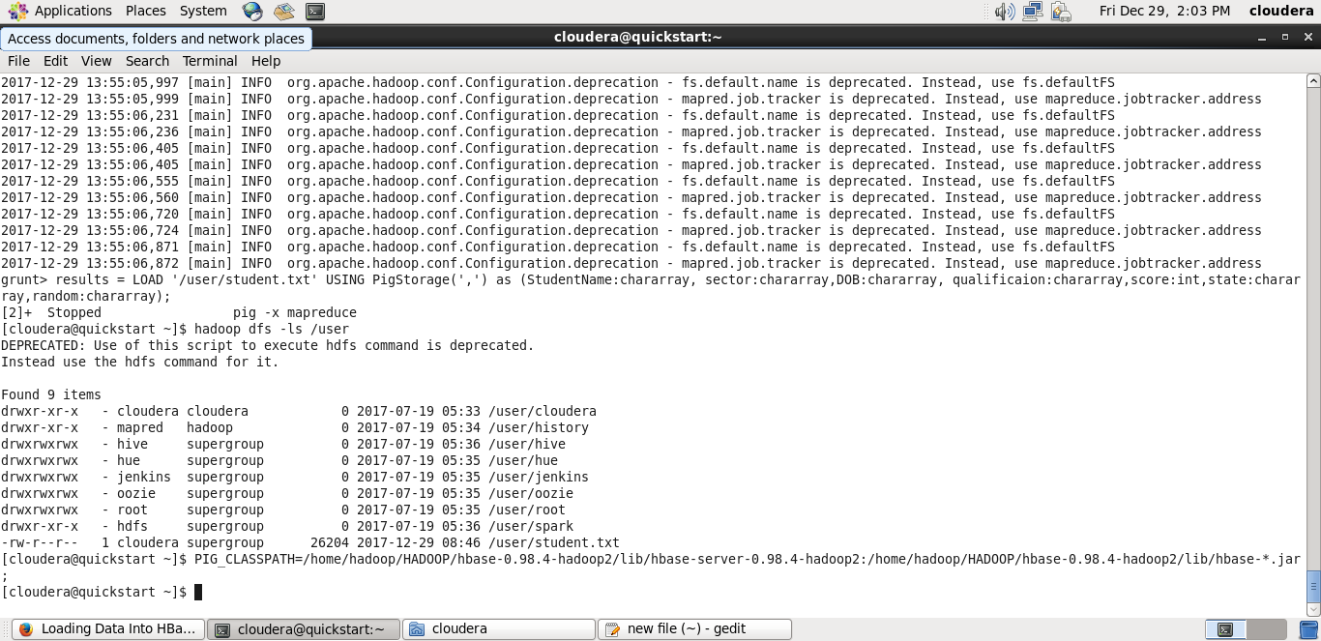

**Load data to pig from HDFS**

results = LOAD '/user/student.txt' USING PigStorage(',') as (StudentName:chararray, sector:chararray,DOB:chararray, qualificaion:chararray,score:int,state:chararray,random:chararray);

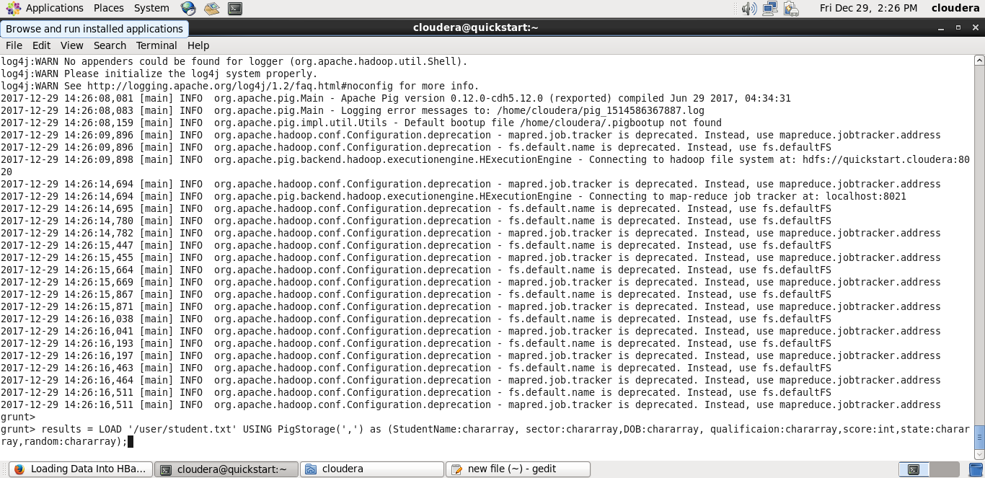

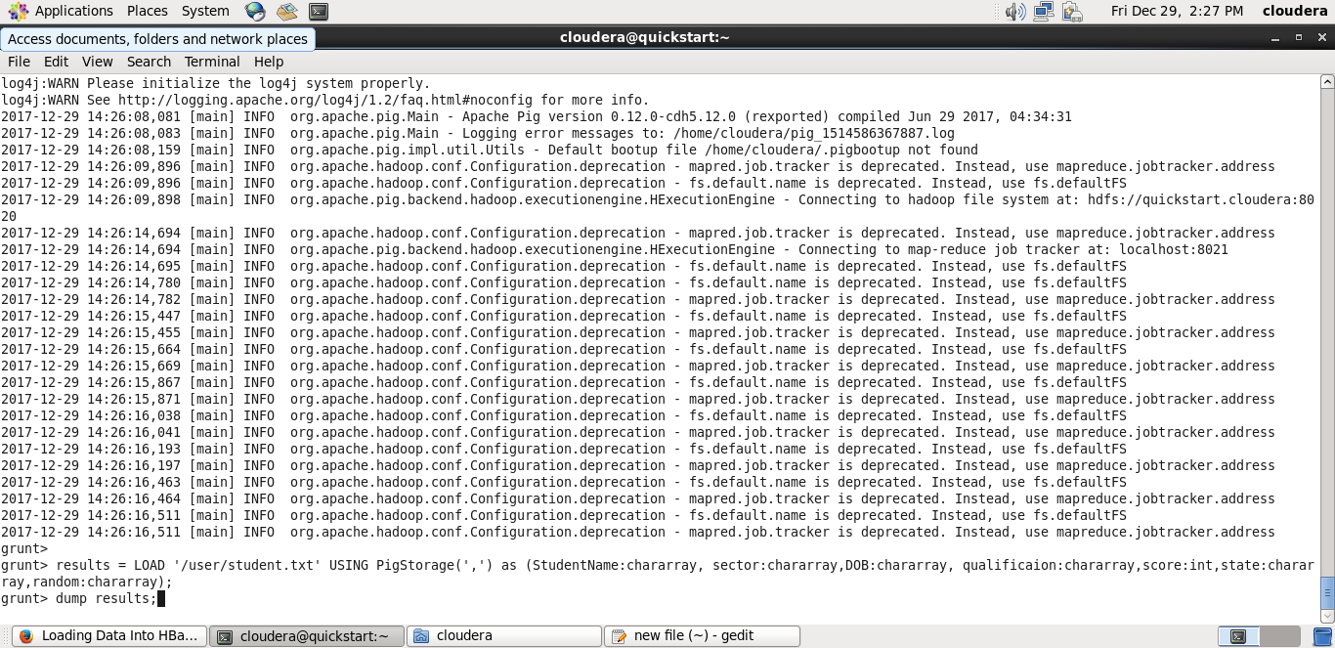

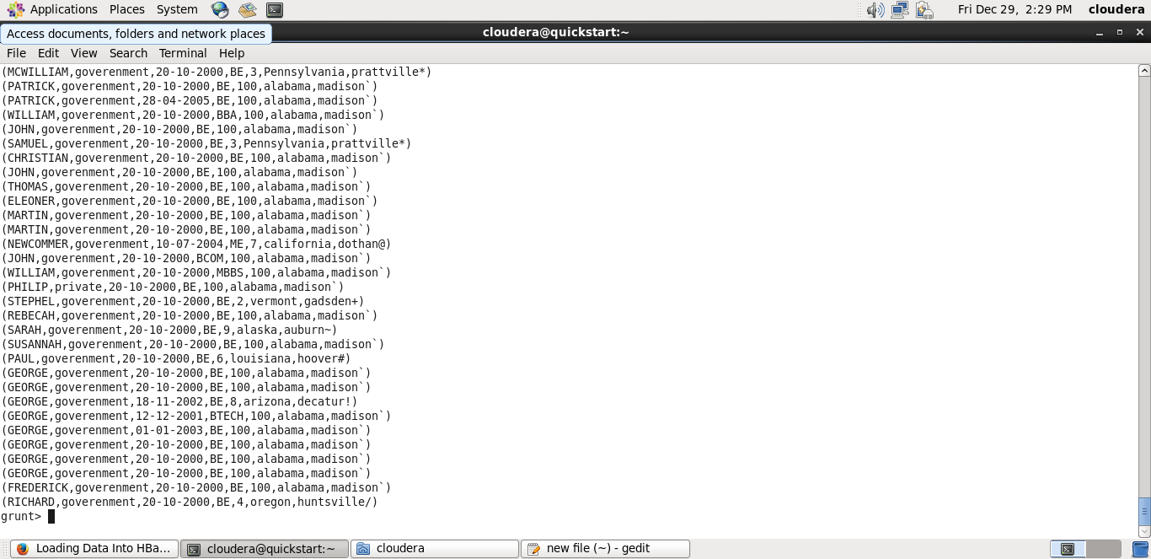

**Load data from pig to Hbase**

STORE results into 'hbase://studentAcad' USING org.apache.pig.backend.hadoop.hbase.HBaseStorage('student_data:StudentName, student_data:sector,student_data:DOB, student_data:qualificaion,student_data:score,student_data:state,student_data:random');

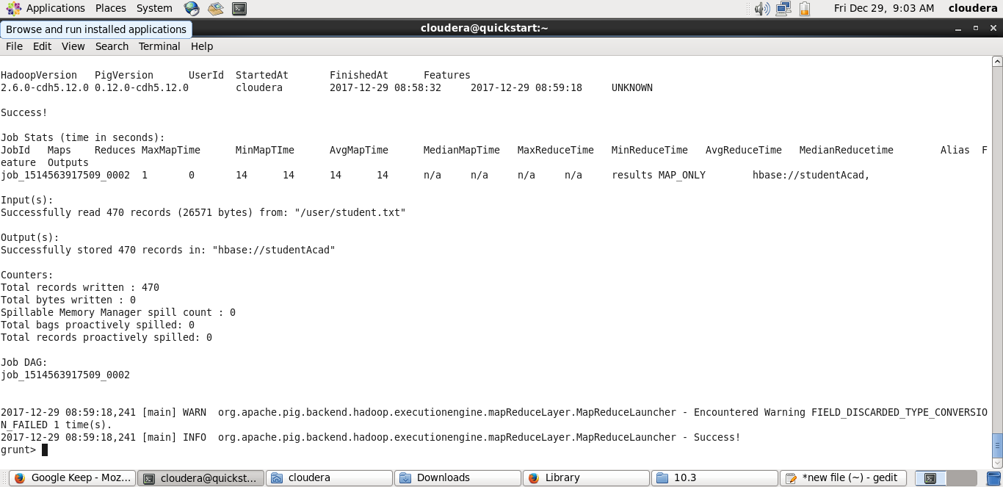

Data in Hbase table

